
Year 7
Investigation 4-Angles
Billiard Ball Bounces

Name: Solutions
Equipment required: 1-centimetre grid paper, protractor, ruler

The game of billiards is played on a large rectangular table that is covered in felt and surrounded by a cushion along the edges. Players use a long stick, called a cue, to hit balls into pockets around the edges of the table. Snooker and pool are variations of the game that have become extremely popular over time. The size of the table can vary from 12 feet (3.7 m) along the larger side to 9 feet (2.7 m), 8 feet (2.4 m) or 7 feet (2.1 m) in length.
When planning their shots, good billiards players use the fact that a ball bounces off the side of a table at the same angle at which it hits, as shown here:
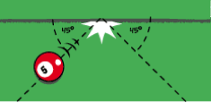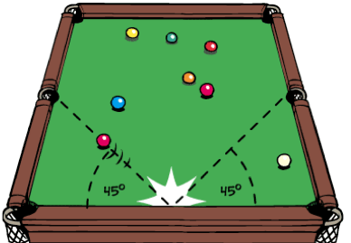

Here, the ball approaches the cushion at an angle of 45° and rebounds at an angle of 45°.
The ball may bounce off the sides several times before it either stops rolling or goes into a pocket. For this investigation, we will assume that the ball keeps rolling until it falls into a pocket.

The Big Question
Can we predict how many times a billiard ball will bounce on tables of different sizes?
Can we predict which pocket the ball will fall into?

Here, the ball is hit from the bottom left corner at an angle of 45° and bounces off the sides of the table three times before falling into the opposite pocket along the short side.

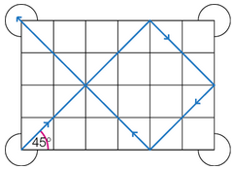

1 (a) To see what would happen if we made the table bigger, use your grid paper to draw a similar ‘table’ to the one above, but make it 6 cm × 8 cm. Starting in the same corner (bottom left), trace the path of a ball hit at an angle of 45°, bouncing it off the sides until the path ends in a pocket. You should find the ball bounces five times and falls into the opposite pocket on the long side.
(1 mark)
Students’ own sketches ✓
(b) What would happen if the table was square?
The ball would go into the opposite pocket ✓
__________________________________________________________________________________
(1 mark)
2 (a) Tables of the following dimensions are drawn on your grid paper.
1 × 2, 1 × 4, 2 × 3, 2 × 4, 2 × 8, 3 × 4, 3 × 6, 3 × 8, 3 × 12, 4 × 5, 4 × 6, 4 × 7, 4 × 8, 5 × 6, 5 × 7,

(b) Starting in the same corner each time, trace the path of the ball hit at an angle of 45°. Count the number of bounces, and also note which pocket the ball falls into.
(15 marks)
Dimensions | Bounces
1x2 | 1 ✓
1x4 | 3 ✓
2x3 | 4 ✓
2x4 | 1 ✓
2x8 | 3 ✓
3x4 | 5 ✓
3x6 | 1 ✓
3x8 | 9 ✓
3x12 | 3 ✓
4x5 | 7 ✓
4x6 | 3 ✓
4x7 | 9 ✓
4x8 | 1 ✓
5x6 | 9 ✓
5x7 | 10 ✓

3 (a) Look at all of the drawings you have of the tables and their ball paths. To help you see any patterns or connections between them, group together the tables that have something in common (use a highlighter or coloured pen to group them). Some of the groups you could make are:
• tables where the pattern traced by the path of the ball is identical
• tables where the ball passes through every square on the grid.

(b) Once you have made these groups, compare the length, width and ’bounce’ numbers for each table in the group. Are they connected in some way? Compare the starting and finishing pockets of the balls in each group. Is there a pattern here?
(5 marks)
1 mark for each up to a maximum of 5. Some patterns for mxn tables.
If n=2m then 1 bounce (bottom right pocket).
If n=km (where k is an integer) k-1 bounces (bottom right pocket if k is odd, top right pocket if k is even).
If n=m+1 then (2m-1) bounces (m even top left pocket, m odd bottom right pocket).
If m=()n then 3 bounces (top left pocket)
If m and n are both odd with a difference of 2, then (m+n-2) bounces.

4 (a) Write a couple of sentences that answer the Big Question (on the first page) about predicting the number of bounces for tables of different sizes.
(2 marks)
To predict how many bounces use the rules above. One mark for each correct sentence. ✓✓

(b) Write a couple of sentences that answer the Big Question (on the first page) about predicting which pocket the ball will fall into.
(2 marks)
Use the rules above to predict the pocket also. One mark for each correct sentence. ✓✓

5 (a) Did grouping your results help you to spot patterns and connections between them?
Which groups were useful?
(2 marks)
Yes ✓  Grouping the similar results shows the patterns ✓

6 (a) Predict the number of bounces and which pocket the ball will fall into for the following table sizes.
(2 marks)
(i) 18 × 27 | (ii) 17 × 19
3 bounces (Top left pocket) ✓ 34 bounces (top right pocket) ✓

